User Manual



Development Team:
“Team Twix”

Stephen Moore, Mariama Barr-Dallas, Michael Tang,

Keith Chang, Justin Tavares, Christopher Pagan
System Name:
Tailored Travels
Supervisor:
Russ Cain
Customer:
Piyush Godbole
Team Twix’s Tailored Travels
User Manual

Table of Contents
Page
- Introduction 3
  - Purpose of This Document 3
  - References 3

- System Overview 4
  - Logging In 4
  - Route Calculations 4
  - Using Google Earth 5
- Administrative Procedures 7
  - Installation 7
  - User Support 7

- Troubleshooting
  - Known Bugs and Limitations 8

Appendix A 9

1. Introduction

  - Purpose of This Document
The purpose of this document is to inform users how to perform expected functions within the software. Administrators should see the Administrator Manual for more detailed instructions regarding setup, installation and maintenance, and function definitions that require administrative permissions.
  - References
TWIX System Requirements Specification documentation by TWIX team members Stephen Moore, Mariama Barr-Dallas, Michael Tang, Keith Chang, Justin Tavares, Christopher Pagan
https://github.com/smoore-ms9/UMBC-CMSC_345_TWIX/blob/master/
Documents/Technical Reports/TWIX_SRS.docx
TWIX System Design Specification documentation by TWIX team members Stephen Moore, Mariama Barr-Dallas, Michael Tang, Keith Chang, Justin Tavares, Christopher Pagan
https://github.com/smoore-ms9/UMBC-CMSC_345_TWIX/blob/master/
Documents/Technical Reports/TWIX_SDD.docx

2. User Functions (The GUI Guide)

2.1 Logging In
To log into the program, simply enter your username and password in the login screen of the application. This is the first screen to display when running the program.
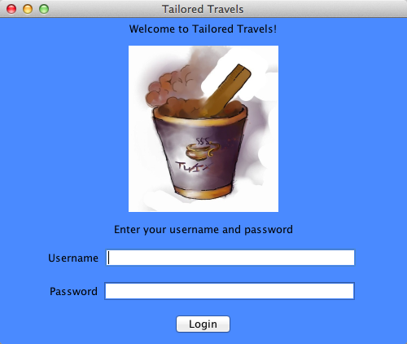
Figure 2.1 – Login Screen
2.2 Route Calculations
On the main screen after logging in, as shown in Figure 2.2, You can either calculate a new route to display on Google Earth, Calculate the distance of a specified route, or click on one of the Waypoints to view its details, as shown in Figure 2.3.
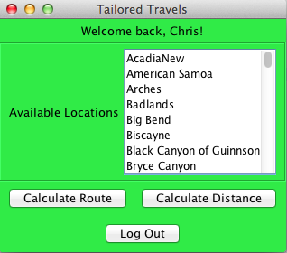
Figure 2.2 – User Panel

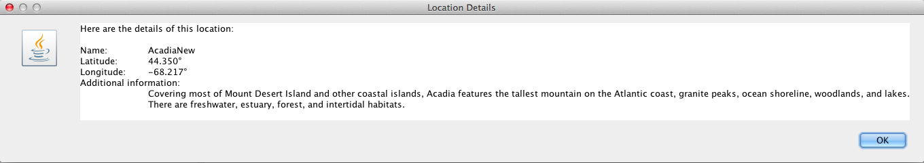
Figure 2.3 – Waypoint Details

2.3 Using Google Earth
After calculating a route through the GUI, a KML file will be saved onto your machine. If you have Google Earth installed, you can open this KML file in Google Earth to view the generated path through all the Waypoints you selected. Each Waypoint is marked on Google Earth by a Placemark, viewable upon scrolling in. An example of a generated path can be seen in Figure 2.4.
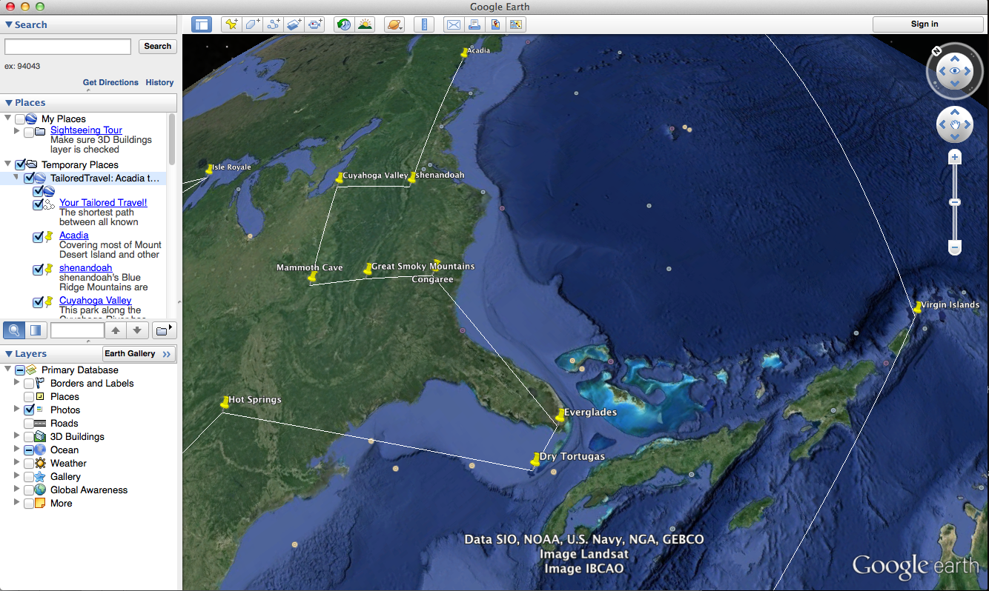
Figure 2.4 -- Generated path displayed on Google Earth

3. Technical Instructions

3.1 Installation
The software package includes a single Java executable, “TailoredTravels.jar.” On a machine with Java 7 or higher installed, simply run this jar file in the directory where you wish to save the output KML files. As a precaution, be sure that the directory has write privileges for the user account of the users of this software, or the program will not be able to save the KML file.

3.2 User Support
Due to constraints on the support team, in addition to its non-existence, no support will be available outside of the included help files. These files are viewable within the application, in the form of clickable icons next to each functional control.
4. Troubleshooting

4.1 Known Bugs and Limitations
- Known Bugs

- Known Limitations
- Calculating route for the route or distance is not accurate because we were unable to write a complex traveling salesman algorithm. We have chosen to do a statistical guess to decide on the shortest route from the starting point to end point to find the route. The algorithm responsible for calculating the optimal route is in the DistCalcDriver class with the method called shortDistanceAlgorithm.

Appendix A - Team sign off, Customer acceptance

Sign off Agreement Between Customer and Contractor

The customer’s signature below indicates that all content herein is of acceptable quality. If any changes are made to this document, the customer must review the content. The revision number of the signature below must match the version number of the document.

Customer Signature Date Notes
Piyush Godbole

Team Review Sign-off

Signing below indicates that each member has read, contributed to and agrees to the content above and the format of this document.

Name Signature Date Notes

Stephen Moore 11/20/13

Keith Cheng 11/20/13
Mariama Barr-Dallas 11/20/13
Michael Tang 11/20/13
Christopher Pagan 11/20/13

Justin Tavares 11/20/13

https://github.com/smoore-ms9/UMBC-CMSC_345_TWIX/blob/master/Documents/Technical Reports/TWIX_CIR.docx

